# Lab: Selenium WebDriver Advanced

This document defines the homework assignments from the ["QA Automation" Course @ Software University](https://softuni.bg/trainings/1584/qa-automation-march-2017).

Please submit as homework a single zip / rar / 7z archive holding the source code or whatever approach is needed to finish your tasks

This homework add new features to your last homework, so feel free just to refactor you last homework. And of course you have to add some new tests.

## Automationpractice Registration negative tests

After last test you can be sure that registration page is open correctly. Now for next tests you can navigate directly to <http://automationpractice.com/index.php>**.** Write at least **five negative tests** against registration form. Your tests have to check **five** **different error messages** in the registration form.

### Examples

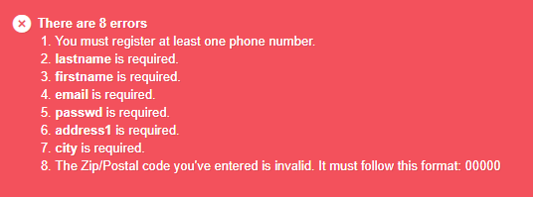

## Interaction Tests

Like you see in DemoQA have another section than registration form. Your task is to write some test for every page in **interaction sections**. Be creative and prepare some automate test in these sections. There is just one condition, number of tests you will have. **Minimum number** of tests for each page in interaction section:

* **Draggable - 3 tests**
* **Droppable - 3 tests**
* **Resizable - 2 tests**
* **Selectable - 2 tests**
* **Sortable - 2 tests**